Done by: Aashish Chaudhary
Date: 01/21/2026
Task: Create NFS share and make it both temporary and permanent mount
Concepts and Tools: Network File Sharing Techniques and Tools like nfs-kernel-server, nfs-common, /etc/export file
Overview:
NFS or Network File Share is essential feature in linux where files or directories can be easily shared across multiple machines or network (if you have one). In this lab, I have showed the base level way of creating a fileshare, and share it across the network. In simple words, I have two VMs (Ubuntu Server, and Desktop version) in my Proxmox, where I shared a directory owned by nfuser user group from Ubuntu Server to the Ubuntu Desktop. Let me show you how I did this:
Before we start, Lets see the general working outline of my project:
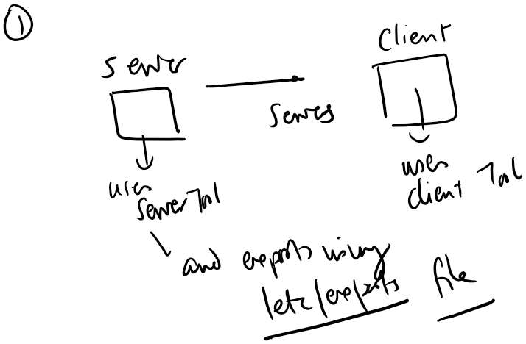
Fig: project outline
- What is the final result?
Here is what I intended to accomplish after my lab:
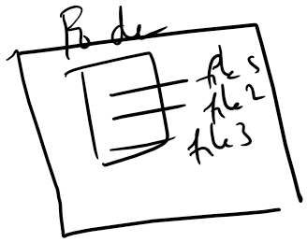
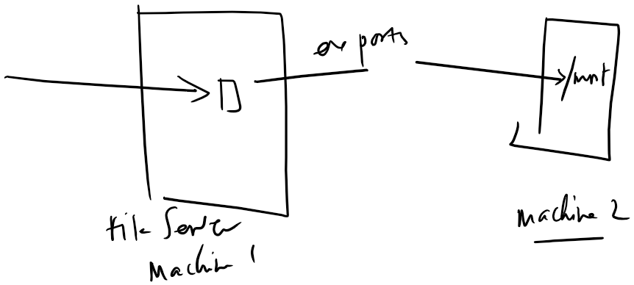

Fig: Expected output

Steps:
- User Creation: Both machine need same users to write to the shared directory. So first nfusers were created in both machines
- Tools Installed: NFS works in Client-Server Architecture, hence, Server needs nfs-kernel-server and Client needs nfs-common. Hence both tools were installed in respective machines.
In Server Machine:
- Shared Directory Creation:
For this, we can use existing ones or create new ones. I created a ‘nfs_share’ in the /srv directory
- Directory Permissions set:
After nfs-share was created, I changed the directory to be owned by nfuser user and nfuser group. In addition, I set the permission to 755 so that only the user can make change to the files in the directory.
- Export file modified:
Next Step is to define export in /etc/export file in which where the Server would export the directory to is defined.
- Changes applied to the Server using
Sudo exportfs -ra

In Client Machine:
-For temporary mount:
Just use the regular mount command and the nfs filesystem gets mounted to your mountpoint
-For Parmanent Mount:
Add the configuration in the /etc/fstab file and test it with either reboot or ‘sudo mount -a’ command.
After doing this, /shared directory in the Server machine is visible at the mount point on the Client Machine. Users with Permissions can make changes to the files and it syncs in both machines at the same time.
Important Things to Remember:
1. Ping must work before creating nfs share and exporting the files.
2. Don’t forget to add Client’s IP in export file.
3. Don’t forget to add Server’s IP while mounting in the Client Machine.
Hence, I have used basic fundamental concepts to create a simple NFS share. In my CLI documentation, I have included all the commands stepwise. It is easier to do this lab on your own if followed in all the steps.

